**Contested Geographies of Sacred Dakota Sites at the Confluence of the Minnesota and Mississippi Rivers**

Max Pursley

A Senior Thesis Proposal

Department of Geography

St. Cloud State University

May 2025

**Abstract**

This study examines how Native and Euro-American perceptions of Indian Mounds Regional Park, Bdóte, and Oheyawahi/Pilot Knob compare, and explores the historical, social, and political factors that have shaped these perspectives over time. Particular attention is given to the ways Dakota interpretations of these sites align with or diverge from the official narratives presented by local administrative bodies, including the Minnesota Historical Society. The analysis also considers the role of memorials, plaques, and other on-site interpretive materials in shaping public understanding of these culturally and historically significant locations. Additionally, the research investigates the influence of public policies related to land use and historic preservation, with a focus on the inclusion or marginalization of Indigenous voices in these processes. Through a combination of archival research and site analysis, the project evaluates the representation and stewardship of these sites. Findings will contribute to broader academic conversations on historical memory, cultural landscapes, and the integration of Indigenous perspectives in heritage preservation and public policy.

**Goals and Objectives**

The overarching goal of this research is to deepen understanding of the cultural, historical, and political significance of three sacred Dakota sites – Indian Mounds Regional Park, Bdóte, and Oheyawahi/Pilot Knob – by analyzing how they are perceived, represented, and memorialized through both Indigenous and Euro-American lenses.

To achieve this goal, this research will seek to answer the following research questions:

1. How do Native and Euro-American perceptions of Indian Mounds Regional Park, Bdóte, and Oheyawahi/Pilot Knob compare and what factors have influenced changes over time?
   1. How do memorials, plaques, and other on-site signifiers characterize these places?
   2. How do Dakota perspectives on these sites align with official historical narratives presented by local administerial organizations, such as the Minnesota Historical Society?
2. How have public policies regarding land use and historic preservation affected these sites, and how have Indigenous voices been included (or excluded) in these decisions?

In doing so, this project aims to critically examine settler-colonial frameworks of place and memory, while fostering deeper engagement with Indigenous geographies, sovereignty, and the central role of Native voices in shaping public narratives, historical interpretation, and the future stewardship of sacred sites.

**Place, Sacred Sites, and Settler Narratives: Literature Review on Indigenous Geographies**

The concept of place is fundamental to the discipline of geography (Cresswell, 2012; Noel, 2009). However, it is also a fluid concept with various uses and applications. For example, physical geographers may define place differently from human geographers. Rather than viewing place simply as a location on a map, it can be understood as the feelings and attitudes people associate with a particular location and the role it plays in their cultural, spiritual, and personal identities (Castree, 2009). Geographer Edward Relph argues that place and community are deeply interconnected, each shaping and reinforcing the other's identity (Relph, 1976). Similarly, the term *topophilia*, coined by geographer Yi-Fu Tuan, describes the emotional attachment people have to a place, whether it be their hometown, house, or a more sacred location (Cresswell, 2012).

From time immemorial, humans have considered certain places to be sacred. A place becomes sacred through human perception (Wall, 2024). Beyond physical features, sacred places derive meaning from religious, cultural, and spiritual connections. Traditions, rituals, and history transform ordinary spaces into sites of deep significance, reflecting the values and identities of those who cherish them (McNally, 2023). For many Indigenous peoples of North America, the relationship between people and place is foundational to their cultures and worldviews. As the Nisga’a tribal government expressed: “Ours is a world of teeming inlets, dense forests, and sleeping volcanoes. It is a land that is as much a part of us as our own flesh and blood” (Atleo & Boron, 2022, p. 1). This deep connection is also reflected in other cultural perspectives. In his study on settler interactions with sacred sites in South Africa’s Venda region, Kgomotso Jackson Phillip Sebola-Samanyanga coins the term “(s)place” to bridge the gap between the concept of space, and the presence of culturally significant places within it, emphasizing how landscapes hold both social and spiritual significance (Sebola-Samanyanga, 2025).

***Settler Characterization of Indigenous Place***

Settler-colonial[1] entities, such as governments, private companies, and settler communities, typically characterize Indigenous places, sacred or not, in two main ways to justify the dispossession of Indigenous peoples from their land. Firstly, there is an idea that a place that has been “profaned” (i.e., polluted or destroyed in some way, such as through economic development) can no longer be considered a sacred place, and thus holds no value to Indigenous people. The logical conclusion of this line of thinking is that, because the place is no longer sacred, there are no qualms with further exploiting and denigrating it. Of course, the notion that because a place is not ‘pristine’ means it is no longer perceived as sacred is incorrect. Many holy sites for major world religions are far from ‘pristine’, yet they are considered holy by the same institutions that would declare polluted Indigenous sacred places as forfeit (McNally, 2023). Second, there is a common argument that Indigenous places are “empty” or a part of “nature.” These justifications usually follow the development of towns, cities, tourist hotspots, or parks. Studying settler heritage and tourism in Dubbo, Australia, Randell-Moon (2024) argues that the development of tourism and its infrastructure depends on erasing the historical violence and racism embedded in these places. This erasure enables tourists to engage with these spaces without confronting the past, ultimately reinforcing colonial narratives and obscuring the true history of the land (Randell-Moon, 2024). While the creation of tourist sites can sever Indigenous peoples' connection to place, so too can the designation of these places as “nature.” This often occurs through the establishment of parks that encompass sacred sites, framing them as part of the “natural world” rather than Indigenous cultural landscapes. This framing has frequently led to the dispossession of Indigenous land and resource rights. In one striking example, the Maasai people of Africa saw their homeland transformed into Amboseli National Park, where they were dehumanizingly regarded as “part of nature,” a characterization that undermines Indigenous connections to place (Ginn & Demeritt, 2009).

***A Brief Overview of the Subdiscipline of Indigenous Geography***

Indigenous geography is a budding and dynamic subdiscipline that centers Indigenous perspectives on land and place, while highlighting Indigenous methodologies and epistemologies. Rather than viewing land as property to be owned by individuals, governments, or other bodies, Indigenous geographies tend to emphasize place as a living entity, containing stories and ancestral presence. Furthermore, Indigenous geographies are largely rooted in community-based epistemologies and practices that are often excluded from mainstream geographic discourse (Herman, 2008). Pickerill (2024) argues that Indigenous ontologies[2] are place-specific and fluid, and are largely resistant to dominant ideas and approaches in geography. Furthermore, Pickerill calls for a re-evaluation of many core concepts in geography in favor of diverse, context-specific understandings of key ideas such as place and space.

**Study Areas**

* This research project focuses on three study sites, each with unique histories and stories: Indian Mounds Regional Park is located to the east of St. Paul, on bluffs overlooking the Mississippi River. At one point, the park contained over fifty burial mounds, some as old as two thousand years. All but six of the mounds were destroyed by Euro-American colonizers in the nineteenth century, largely due to urban development and road construction (Friends of the Mississippi River, 2021).
* Bdóte, located on Pike Island at the confluence of the Minnesota and Mississippi Rivers, is considered, according to Dakota oral tradition, the place where the Dakota people and culture were created. Throughout history, this sacred place has been claimed by the French in 1689, and eventually the Americans came to “own” the land after the Louisiana Purchase in 1803. In 1819, construction of Fort Snelling began on the bluffs overlooking the site, less than two miles away. Pike Island, named after American explorer and general Zebulon Pike, was also the site of a concentration camp built to intern mostly Dakota women and children in the aftermath of the 1862 U.S.-Dakota War. Bdóte is now a part of Fort Snelling State Park (Westerman & White, 2012).
* Oheyawahi/Pilot Knob is located on the bluffs south of Bdóte, overlooking the Minnesota River. The site is located within the city of Mendota Heights, which controls it as trust land. Historically, Dakota people have used the site for medicine ceremonies, prayer gatherings, and burial. In 2002, there was an attempt to build a large housing development on the land, which was blocked due to Dakota activism and support from the local community (Cox & Krisa, 2015).

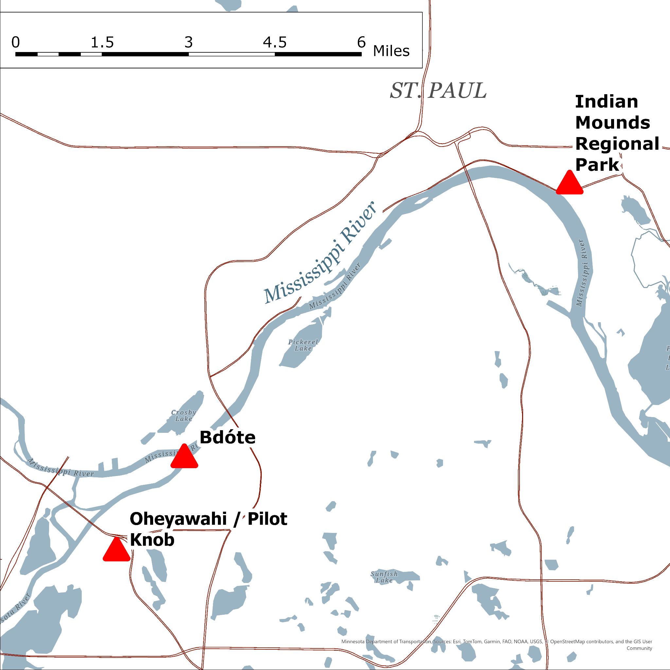

Figure 1: The three study areas mapped in relation to the Mississippi and Minnesota Rivers, as well as St. Paul. This figure was created by using ArcGIS Pro software and base map data from Esri (Esri, 2025) as well as National Highway System data from the Minnesota Department of Transportation (MnDOT, 2022).

**Methods**

Two primary methodologies will be employed to conduct this research. The first is archival research analysis, similar to the work done by Bruce White and Gwen Westerman (2012) for their book *Mni Sota Makoce: The Land of the Dakota*. White and Westerman demonstrate this methodology by using a wide range of archival materials, including government documents, treaty records, journals, letters, and historical maps. Utilizing this methodology allows for the analysis of the perceptions of Dakota sacred sites that organizations such as the Minnesota Historical Society and other administrative bodies hold and facilitates tracing how those perceptions have been shaped over time through policy decisions, historical interpretation, and land use planning. Archival research also allows access to important historical Dakota perspectives on the three sacred sites under study: Indian Mounds Regional Park, Bdóte, and Oheyawahi/Pilot Knob. Understanding how Dakota people have historically interacted with these places provides valuable context for how these sites are interpreted today. Additionally, this approach enables comparison between Dakota perspectives uncovered through archival sources and the ways in which these locations are characterized by institutions such as the Minnesota Historical Society and other governing bodies. Both primary and secondary sources will be analyzed, with materials sourced from databases including the Minnesota Historical Society, the University of Minnesota Archives, and the St. Cloud State University Archives.

The second methodology is site-based qualitative analysis, which involves visiting these sacred sites to observe, record, and analyze how they are presented to the public. This includes closely examining commemorative plaques, memorials, signage, and other aspects of each site to understand how each place is characterized. Special attention will be given to the language used, the perspectives being featured or omitted, and the overall narrative conveyed through these public displays. In *“*Memorials and Monuments,*”* Alderman, Brasher, and Dwyer (2020) emphasize the powerful role that memorials and plaques play in shaping public understanding of places. They demonstrate how these commemorative markers frame the significance and history of a site not only through what is remembered and what is left out, but also through the perspectives of the people or organizations that create and install them. This approach will directly address research question 1b, which inquires as to how markers, including memorials and plaques, characterize the three study sites.

These two methodologies will work in tandem, as the archival research will provide important context for interpreting the memorials and commemorative elements present at each site. By understanding the historical narratives, policy decisions, and institutional perspectives that have shaped public memory over time, this study will be positioned to analyze how these forces manifest in the physical and symbolic landscape of the sites today. The memorials, plaques, and other commemorative markers at these sites are often deeply intertwined with the historical narratives that may emerge through archival and historical research. Whether these physical markers reinforce or contradict those narratives will be an important aspect of the analysis. The data collected will largely be qualitative and manually gathered, while quantitative data may ultimately be ancillary to this project (e.g., a table documenting how many markers at Indian Mounds Regional Park commemorate Indigenous connections to the site versus how many commemorate an airway beacon). Furthermore, images of particularly relevant markers at each site will be included to support the analysis.

**Summary and Contributions**

This project draws on concepts from cultural, historical, and Indigenous geography to analyze how Indian Mounds Regional Park, Bdóte, and Oheyawahi/Pilot Knob are presently, and have been historically, perceived by members of the Dakota community and the Euro-American community in Minnesota. Through analyzing archival data, this project seeks to highlight evolving characterizations of these sacred sites, paying particular attention to the ways institutional narratives have framed these places through public policy, interpretation, and land use planning. By combining this archival research with site-based qualitative analysis, the study will assess how public memorials, signage, and markers reinforce or challenge prevailing narratives. Ultimately, this research aims to uncover how settler-colonial perspectives continue to shape public memory and how Indigenous voices are being included, or excluded, in the stewardship and interpretation of these culturally significant places.This research contributes to the discipline of geography by engaging with several subdisciplines: cultural geography, historical geography, and Indigenous geography. This project offers a place-based analysis of how sacred places are interpreted, perceived, and represented, specifically highlighting ways these representations are shaped by settler-colonial entities and contrasted with Indigenous perspectives. By exploring these contrasting characterizations of these places, this project can inform government bodies, historical societies, planning commissions, and other administerial organizations on the importance of meaningfully engaging with Indigenous communities that may be affected by decisions related to land use, site stewardship, as well as public representation of these sites (e.g., writing Minnesota history books that include or interpret these locations, or others). In doing so, this research advocates for greater openness and inclusiveness by Euro-American institutions and individuals to engage with those whose cultural, historical, and spiritual connections to these sites have long been marginalized or ignored. This research also calls for greater willingness among geographers to engage with and incorporate Indigenous ontologies and epistemologies in their work, as the inclusion of these perspectives and voices serves to enrich and expand the discipline of geography.

**Timeline**

The proposed timeline for this project encompasses eight months, with most of the research taking place over the summer months of June, July, and August. This will allow sufficient time to gather as much data as possible, with the summer months being particularly beneficial for gathering data via site-based analysis, as the weather will not prohibit travel to the study areas, and snow/ice will not obscure plaques, statues, and other commemorative landmarks. Archival research will take place during the majority of the proposed timeline, as that can be done at nearly any time, and many pieces of data will need to be located, analyzed, and interpreted. Once site-based analysis concludes with the onset of autumn in September, data compiling and organization will begin, and so too will the finalization of the project, ultimately preparing for presentation and publication in December of 2025. Figure 2 highlights this timeline in the form of a Gantt chart.

| **Research** | May | June | July | August | September | October | November | December |
| --- | --- | --- | --- | --- | --- | --- | --- | --- |
| Archival |  |  |  |  |  |  |  |  |
| Site-based |  |  |  |  |  |  |  |  |
| Finalize |  |  |  |  |  |  |  |  |

Figure 2

**References**

Alderman, Derek, Jordan Brasher, and Owen Dwyer. “Memorials and Monuments.” In *International Encyclopedia of Human Geography*, 2nd ed., edited by Audrey Kobayashi. Amsterdam: Elsevier, 2020. https://doi.org/10.1016/B978-0-08-102295-5.10201-X

Atleo, Clifford, and Jonathan Boron. "Land Is Life: Indigenous Relationships to Territory and Navigating Settler Colonial Property Regimes in Canada." *Land* 11, no. 5: 609. 2022. https://doi.org/10.3390/land11050609

Castree, Noel. “Place: Connections and Boundaries in an Interdependent World.” In *Key Concepts in Geography,* edited by Clifford et. al., 153-172. Thousand Oaks, CA: SAGE Publications Ltd, 2009.

Cox, C., & Krisa, D. (2015). “Pilot Knob/Oheyawahi” in *Religions in Minnesota* (Carleton College digital project).

Cresswell, Tim. *Place: A Short Introduction.* Malden, MA: Blackwell Publishing, 2012.

Esri. "Environment Surface and Water Label" [basemap]. 1:49,109. "Environment Base". June 21, 2024. https://www.arcgis.com/home/item.html?id=a69f14ea2e784e019f4a4b6835ffd376 (April 13, 2025).

Friends of the Mississippi River (2021). “Indian Mounds Regional Park: Restored land in a sacred place.”

Ginn, Franklin, and David Demeritt. “Nature: A Contested Concept.” In *Key Concepts in Geography,* edited by Clifford et. al., 300-311. Thousand Oaks, CA: SAGE Publications Ltd, 2009.

Herman, R.D.K. “Reflections on the Importance of Indigenous Geography.” *American Indian Culture and Research Journal* 32, no. 3 (2008): 73–88.

McNally, Michael. “The Sacred and the Profaned: Protection of Native American Sacred Places That Have Been Desecrated.” *California Law Review* 111 (2023): 395-465

Minnesota Department of Transportation (MnDOT). “National Highway System in Minnesota.” June 17. 2022. ArcGIS Online. https://www.arcgis.com/home/item.html?id=6d6ae6c4dfe1407fa0efc914c12895e7 (April 13, 2025).

Pickerill, Jenny. “Unsettling Geography: Enacting the Politics of Indigenous Ontologies.” *Agoriad: A Journal of Spatial Theory* 1 (2024): Article 1.5.

Randell-Moon, Holly E. K. “Seeing Like a Settler: Place-Making, Settler Heritage, and Tourism in Dubbo, Australia.” *Tourism Geographies* 26, no. 6 (2024): 993–1011. https://doi.org/10.1080/14616688.2024.2380321.

Relph, Edward**.** *Place and Placelessness*. London: Pion, 1976.

Sebola-Samanyanga, Kgomotso J. P. “(S)places and Peace of (S)place: Venḓa’s Sacred Sites.” *International Planning Studies*, February 4, 2025. https://doi.org/10.1080/13563475.2025.2460706.

Veracini, Lorenzo. *Settler Colonialism: A Theoretical Overview*. Basingstoke: Palgrave Macmillan, 2010.

Wall, Stephen. “Sacred Sites, Sacred Rights: Preparing the Next Generation of Protectors.” *Tribal College Journal* 36, no. 1 (September 1, 2024): 22–26. https://research-ebsco-com.scsuproxy.mnpals.net/linkprocessor/plink?id=fe6556a7-118c-3407-89b2-14960d8f550a.

Westerman, Gwen, and Bruce White. *Mni Sota Makoce: The Land of the Dakota*. St. Paul: Minnesota Historical Society Press, 2012.

1. *Settler colonialism* is a form of colonial domination in which settlers seek to permanently occupy and assert sovereignty over Indigenous lands (see Veracini 2010).
2. “An ontology is a way of knowing what exists, of perceiving and interpreting the world and its reality,” Jenny Pickerill, “Unsettling Geography: Enacting the Politics of Indigenous Ontologies,” *Agoriad: A Journal of Spatial Theory* 1 (2024): Article 1.5.